REPORT FOR: | CONSULTATIVE FORUM
Date of Meeting: | 6 February 2019
Subject: | Independent Visitors Service
Key Decision: | No
Responsible Officer: | Peter Tolley, Divisional Director Children and Young People Services
Portfolio Holder: | Councillor Christine Robson, Portfolio Holder for Young People and Schools
Exempt: | No
Decision subject to Call-in: | N/A
Wards affected: | All Wards
Enclosures: | None

Section 1 – Summary and Recommendations

This report sets out to provide information on the Independent Visitors Service to the Corporate Parenting Panel.

Section 2 – Report

Introductory paragraph

- The Children’s Act 1989 places a duty on a Local Authority to appoint an Independent Visitor for any ‘Looked after Child’ if they believe this to be in the child’s best interest and the young person has consented to the support.

- Independent Visitors are there to ‘Advise, Assist & Befriend’ the young person, as well as to encourage them to exercise their views. Independent Visitors are child focused and support the care plan for the child; they are there in a complementary role and not to function as a substitute social worker, parent or carer.

- Sova’s Independent Visitors are volunteers who provide consistent long term support to children and young people who are looked after by Harrow local authority, with ages of referrals ranging from 7 - 18.

- The project is commissioned and funded solely by Harrow Council’s Children and Young People’s Services.

Options considered

None – Report is for information only

Background

- Independent Visitors are there to be a consistent and independent presence in the lives of the young people they work with. This includes independent living skills, attending meetings, liaison, ensuring understanding of information, transitioning from the leaving care team, signposting, communication skills, building confidence and social inclusion.

- However, the real power of the service is the ability of volunteers to reach out to young people often suffering from isolation due to their circumstances, their behaviour, language, cultural barriers, emotional issues or physical and mental disabilities in order to give them someone to spend quality time with.

- This can mean that young people are given an extra chance, moving from full time care into semi-independent and then full independence, to have gained some of the life skills and emotional intelligence to deal with the different and varied relationships they will need to form to succeed in education, a career and in their own personal lives.

- Sova was awarded the contract to deliver Harrow IV project, commencing delivery in November 2015.

- In November 2015 a total of 26 relationships were transferred from the incumbent to Sova. The experience is that when IV services are handed over we expect to see a significant drop off in relationships, sometimes as high as 50%.

- This is caused by a combination of young people and volunteers using the change in provider as an opportunity to end their relationship. Young people may have reached an age where they want to end the relationship, have reduced the frequency of visits; and volunteers may have been matched with a young person for a considerable amount of time and their personal circumstances have changed; with both parties using the move to a new provider as a “legitimate” excuse to end the relationship.

- Sova reporting shows that by April 2016 the open relationship numbers had dropped to 6; during 2016 this peaked to 10 during August to October; during 2017 relationships dropped as low as 3 but remained fairly static at 6 for the majority of the year; and in 2018 remained at 6 until November when it rose to 7. This performance constitutes around 20% performance rates.

- During November 2015 to December 2016 Sova received a further 17 referrals for young people to receive an IV. In 2017, 11 referrals were received, with a further 6 received in 2018. This shows a significant decline in the number of young people being referred to the service.
Context and impacts factors are discussed in further sections of this document.

Current situation

- Currently there are 7 open and active relationships. With Sova data showing 24 available volunteers and a further 13 trained and going through the recruitment process. Sova IVs are fully briefed on the needs of children and young people and are acutely aware of the need to provide consistency and stability.

- Volunteer IVs need no formal qualifications, but a genuine and active interest in the welfare of CYP and successful progression through Sova’s six stage Safer Volunteer Recruitment.

This involves:
• 30 hours Certa Accredited training level 2 for Independent Visitors;
• Two interviews;
• Enhanced DBS;
• 2 References;
• Shadowing with volunteers; and
• Undertaking a suite of accredited training on safeguarding, boundaries and access.

- No volunteer is permitted to have contact with service users until all six stages have been fully completed, with each stage having a ‘safe’ action which must be undertaken.

- Together young people and their Independent Visitors have enjoyed the cinema, the Tate museum, the Science museum, walking trips along the Southbank and around Westminster, bowling and walks in the park.

Resources, costs

Service | Monthly Rate Per Child (£) | Total Cost Per Annum
Rate for one Independent Visitor for one child/young person | £102.04 | £1,224.48
Rate for 24 Independent Visitor(s) | £102.04 | £29,387.52
Rate for 30 Independent Visitor(s) | £102.04 | £29,387.52
Rate for more than 30 Independent Visitors | £81.50 | £978 per additional match

Staffing/workforce

- There have been a number of staff transitions since the service went live in November 2015. The first period of transition was when the role of Volunteer Co-ordinator and Support Officer were made redundant to create one Case Officer role with increased hours was created. This process was not taken lightly and unfortunately meant that one member of the team was made redundant through this process.

- The Case Officer remained in post until they left the role on 1st December 2016. The service went out to advert and completed competency and value based interviews in January. The successfully candidate has been in post since 9th April 2017 and works 17.5 hrs per week on the project.

- The Case Officer is based at Sova’s office at Kings Cross but has access to the Civic Centre and is based here every Tuesday. This ensures that the Case Officer has a strong relationship with the Looked after Children teams.
- Staff have also continued to attend the London Independent Visitor Network meetings which provides an opportunity to share best practise and processes regarding IV recruitment, the matching processes, referrals.

- In recognition of the advantages of this peer information sharing, the new Sova Independent Visitors Network has been put in place. This has resulted in increased communication between the different IV services UK wide and culminate in the first meeting which took place in June 2017. There have been subsequent meetings where best practise across the organisation has been shared. This has led to better shared resources across the organisation.

Performance Issues

- The service has had a number of challenges while it has been delivering the service.

- Transfer – The first challenge encountered was when the service provision was transferred from the incumbent provider to Sova as Sova received minimum volunteer information from them. There were further barriers to overcome with the existing volunteer pool arranging them attending safeguarding training, DBS checks and other aspects that would allow them to meet the minimum requirements to be considered a Sova volunteer. Through this process 3 volunteers were de-selected and 2 suspended, to ensure we had safe activity.

- DBS – A further challenge was the time in which DBS were being returned, some taking as long as 6 months to be completed. This meant larger numbers of volunteers were trained but could not be deployed until their DBS had been returned and they were cleared for the role. This lead to volunteers disengaging through the process and never being available to be matched. The organisation now use online DBS service which has dramatically changed the timescales in the return of each DBS.

- Staffing – While the service was quick to undertake a recruitment drive following the departure of the Case Officer, it took 4 months to have the new worker in post. The Programme Manager maintained the matched relationships and liaising with the volunteers in the interim, but this was a period where there was no new activity.

- The most important aspect of delivery and contacts is the number of visits that young people are receiving. Records show that in:

2015/16 - 72 mentor visits were recorded; totalling 197 hours of activity;
2017 - 21 mentor visits were recorded; totalling 80.4 hours of activity hours; and
2018 - 122 mentor visits were recorded; totalling 128 hours of activity.
- Sova still remains committed to the service continuing, and is always looking to improve the performance of the service.

- There is still a priority need to increase demand within the LAC team. This needs to be addressed by Sova proactively promoting the service, and also evidencing that matches will occur and the benefit of making referrals.

- Partner relationships - The youth participation officer has also proven to be an excellent source of knowledge around the different and varied services/opportunities in Harrow for young people. The service is discussed by Shana with each child she meets with.

- Ofsted – The service was a part of the Ofsted Inspection. The Local Authority was awarded Good and some recommendations were made about the IV service. The main recommendation was to have closer working links between the Complaints team, advocacy and IVS. This is something that the services are looking to improve on.

Legal Implications

None

Financial Implications

- The contract value for this service is £30,000 per year; the contract is for 3 years and 5 months. The current payment mechanism places 100% of the financial risk on the provider.

Equalities implications / Public Sector Equality Duty

- Harrow is a diverse borough, having 63.8% of its population from the BME (Black and Minority Ethnic) communities.

- On this particular service Sova have an 80/20% split of female to male volunteers. With 10% are aged between 18 - 25 years, 70% 26 – 35 years, and 20% over 36 years.

- 20% did not wish to disclose their religion, 40% stated they had no religion, 20% stated they were Muslim, and 20% Hindu.

Ethnicity | Percentage of Volunteers
Asian or Asian British | 30%
Black or Black British | 10%
Do not wish to say | 10%
Mixed | 10%
White | 40%

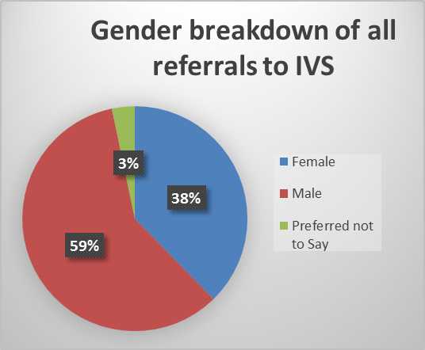

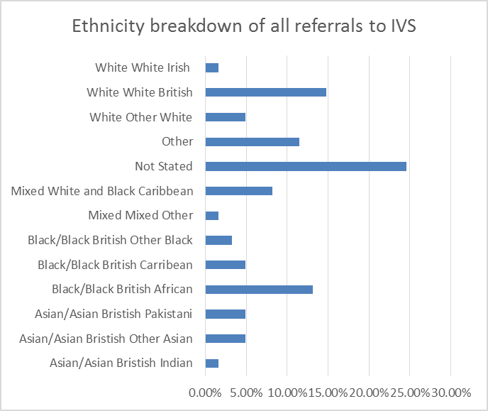

- Data recorded shows that nearly 43% of young people reported being from a BaME community, over 11% identified as being from another group not listed, nearly 25% chose not to provide the information and only 21% identified as being from a White or White sub group.

- The graph above shows the various nationalities of young people referred for an IV.

Council Priorities

- The Council’s vision:

Working Together to Make a Difference for Harrow

The Independent Visitors Service for looked after children directly contributes to the council’s vision and priorities by:

- Making a difference for the vulnerable
- Making a difference for communities
- Making a difference for families

Section 3 - Statutory Officer Clearance

 |  |  | on behalf of the*
Name: Jo Frost | √ |  | Chief Financial Officer
Date: 23 January 2019

Ward Councillors notified: | NO, as it impacts on all Wards
EqIA carried out:  EqIA cleared by: | NO  Report is information only

Section 4 - Contact Details and Background Papers

Contact: Priya Ganatra, People Services Commissioner 020 8420 9237 priya.ganatra@harrow.gov.uk

